Shrimp Task Force Meeting
Wednesday, March 22, 2023, 10:00am
Terrebonne Parish Main Library
151 Library Drive
Houma, LA
I. Pledge of Allegiance
II. Roll call and introduction of guests

Voting Members Present:
Rodney Olander
Acy Cooper, Jr.
Kristen Baumer
Alan Gibson

Voting Members Absent:
Lance Nacio
Jeff Drury
Phillip Tran
Andrew Blanchard
Randy Pearce
Chalin Delaune

Non-Voting Members Present:
Harry Vorhoff in for Olivia Ledet via webinar
Peyton Cagle
Jack Isaacs

Non-Voting Members Absent:
Edward Skena
Gene Cavalier
Justin Gremillion

III. Rodney Olander motioned to approve the January 4, 2023 meeting minutes, 2nd by Alan Gibson. Motion carries.

IV. Rodney Olander motioned to amend the agenda by changing item F. under New Business to read, ‘To Discuss and Consider Funding and Possible Amendments to Act 372, the Shrimp Labeling Bill, 2nd by Kristen Baumer. Motion carries.

Rodney Olander motioned to amend the agenda to add an item under New Business, G. To Discuss and Consider Authorizing the Chair to Approve Comments on the National Seafood Strategy Plan drafted for the seafood industry consider funding, 2nd Kristen. Motion carries.

Julie Falgout stated that the National Seafood Strategy is looking at food safety, fair-trade, will have a conference call on Friday

Rodney Olander motioned to approve the March 22, 2023 meeting agenda as amended, 2nd by Kristen Baumer. Motion carries.

V. Financial Report
Remaining Fund Balance- $677,042
Remaining Budget Balance- $226,876

Kristen Baumer motioned to approve the financial report as presented, 2nd by Alan Gibson. Motion carries.

VI. The shrimp task force was presented with an updated Federal Shrimp Permit Report

Kristen Baumer suggested sending out letters 60 days before expiration for these permits as a reminder before the expiration; requested that Sea Grant help notify these upcoming individuals whose permits are set to expire soon

VII. New Business
- To hear an update on the matter of Louisiana State v. Department of Commerce, et al.
Acy Cooper stated that the case went to court the first time and said the State didn’t have a standing went before a three panel judge, waiting on the federal court to make a decision on standing, are under litigation and are still fighting TEDs. Law is still in effect and you have to pull TEDs
- Jack Isaacs provided a presentation on imports of the U.S. shrimp products 2022
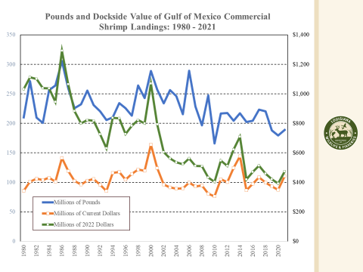
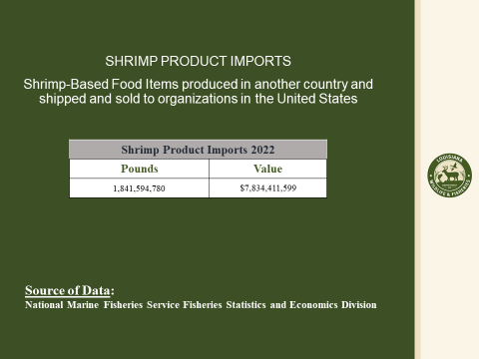
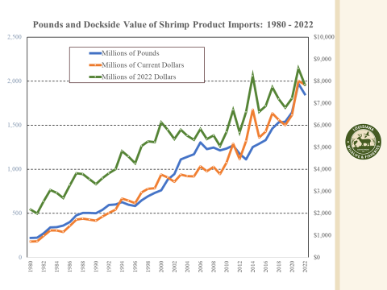
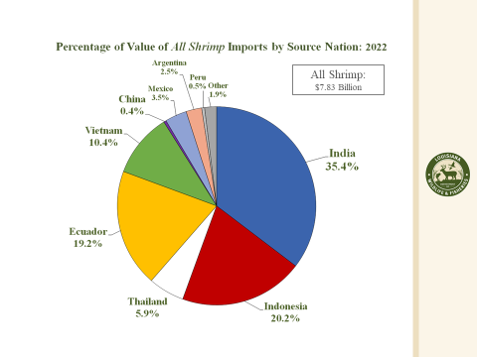
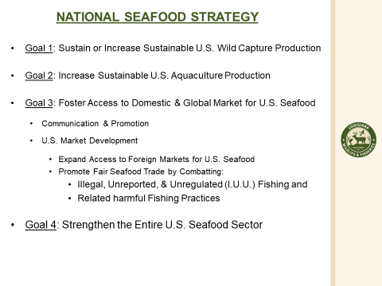
- Brian Shinault provided an update on the STF lobbyist efforts and future planning
Brian Shinault stated that over the last 60 days we have been made aware that Congressman Higgins has introduced a bill, HR1057 which we are in support of. The bill is in the Energy and Commerce Committee. American Stategic Partners has been engaging with representatives across the country on both sides of the aisle, gaining support and have the bill passed. Expect that Congressman Higgins’ office should be issuing a dear colleague letter, which goes around to members. Expect to have some meetings scheduled coming up with the FDA and other members of the administration, once the meeting is set will coordinate with the STF to see if any of the members would like to participate. A few days ago the FDA release a report on food safety, particularly with imported shrimp and imported seafood. Want to speak to the FDA about what is in policy now is being enforced. The conversation is active, provide something to the FDA on what we would like to see the FDA do as far as what policies the industry would like to see changed, next week engaging with the administration, need to work with the STF to draft a 1-3 pager on goals to present to the FDA. Also working on marketing and branding for the industry, working on press coverage on the bill and the industry’s efforts.
Acy Cooper asked if it was possible to get the Governor’s office to write a letter of support for this legislation (HR1057)
Alan Gibson stated that it is very important that someone within the state/ Governor’s office is a representative and pushing this bill and supporting the industry
- The board discussed Monterey Bay shrimp sustainability rating
Acy Cooper stated that the lobster industry sued Monterey Bay over their red listing; a few of the STF board members can try and go talk to AG Jeff Landry to see what can be done on this, the task force plans to set up a meeting soon, plans to speak with CTF chairman as the crab industry is red listed as well
Peyton Cagle stated that the crab fishery is also red listed if the industry wanted support in pursuing this further
- Update on the Shrimp Task Force Washington, D.C. trip
Acy Cooper stated that Brian Shinault with American Strategic Partners did a great job speaking on the issues, not happy with a couple of the meetings, suggested the STF making more than one trip up to D.C. a year, feel there will be some momentum with the representation the task force has in D.C. now
Andy Gibson stated that the STF met with Senator Kennedy, had good conversation but were told basically that he could do nothing for the industry, do not feel the industry has much support in Washington, D.C.
There is a bucket of money to help fund additional inspections that goes into the general fund, tariff money, suggested instead of gas reimbursements to subsidize the shrimp industry
- The board discussed and considered funding to support possible amendments to ACT 372, the shrimp labeling bill
Acy Cooper stated that LDWF drafted the bill and one of the things being added is LDWF enforcement being allowed to enforce and inspect
Amendments: Section C.- in addition to any state sanitary code anyone who violates it for the 1st time would be subject to a penalty of up to- $1000, 2nd offense would be a penalty not exceeding $2000 and for a 3rd and subsequent offense- up to $5000 and subject to losing license until the violation is fixed; there was also amendments at the very end, Section F. was added which states that LDWF will be able to enforce this code and that civil penalties collected would go into the Conservation Fund
SPMB to seek funding for enforcement, but it was recommended that the STF dedicate up to $100,000 for enforcement. LDWF enforcement would do these inspections on their off or overtime
Kristen Baumer suggested getting the bill passed then consider funding
Kristen Baumer motioned to support funding of up to $100,000 and no more than 25% of the total annual cost for LDWF enforcement for the first year, if the bill passes, 2nd by Rodney Olander. Motion carries.
- The board discussed and considered authorizing the Shrimp Task Force chairman to approve comments on the National Seafood Strategy Plan
Julie Falgout provided information on the program
Purpose: The National Seafood Strategy, outlines our direction for supporting a thriving domestic U.S. seafood economy and enhancing the resilience of the seafood sector in the face of climate change and other stressors. Our vision is to ensure that: ● U.S. seafood continues to be produced sustainably ● The U.S. seafood sector contributes to the nation’s climate-ready food production and to meeting critical domestic nutritional needs ● U.S. seafood production increases to support jobs, the economy, and the competitiveness of the U.S. seafood sector ● Supply chains and infrastructure are modernized with more value-added activity in the United States ● Opportunities are expanded for a diverse and growing seafood workforceRodney Olander stated that fuel subsidies, more in favor of subsidizing the shrimp price, try to generate a letter on behalf of all the industry
Strategy Framework: The National Seafood Strategy focuses on NOAA Fisheries’ work to sustainably manage marine fisheries and produce seafood responsibly, based on sound science. It is one of a suite of strategies that describes how we will support the nation’s fisheries and execute our mission in the face of climate change, market disruptions, and new ocean uses. The National Seafood Strategy also allows NOAA Fisheries to address important national issues such as the resilience of coastal fishing communities; the financial viability of the seafood industry; the effects and opportunities of international trade; and the importance of seafood to nutrition, food security, food sovereignty, subsistence fishing, and traditional Tribal fishing rights. To implement the Seafood Strategy, NOAA Fisheries will partner with state and other federal agencies, the National Sea Grant College Program, Tribes, non-government organizations, fishermen, seafood farmers, and other stakeholders to address the challenges facing the seafood sector, especially when resources are limited.
GOALS: GOAL 1: Sustain or increase sustainable U.S. wild capture production, GOAL 2: Increase sustainable U.S. aquaculture production, GOAL 3: Foster access to domestic and global markets for the U.S. seafood industry
Alan Gibson motioned to authorize the Shrimp Task Force chairman, Acy Cooper, to approve comments on the National Seafood Strategy once the plan has been reviewed and approved by the Shrimp Task Force via email, 2nd by Rodney Olander. Motion carries.
Acy Cooper and Kristen Baumer were appointed the POC for this plan
VIII. Public Comment
Acy Cooper suggested sending members that don’t attend and haven’t been coming for the last three meetings a letter; discussed possibly sending out an email that the task force will be taking action in the future, possible item for next meeting, the task force plans to start enforcing the rules
Rodney Olander stated that the St. Mary Parish Tourism is hosting national shrimp day May 10
Rocky Decharo stated that there are issues with the proposed Gulf wind farms; BOEM update for future agenda item
Julie Falgout provided information on a Fisheries & Seafood Leadership Program
Building a Network of Louisiana’s Future Fishing and Seafood Industry Leaders
The program is launching in 2023 to help enhance leadership in the Louisiana Commercial Fishing and Seafood Industry.

The Louisiana Sea Grant Fisheries & Seafood Leadership Program (FSLP) is a one-year program divided into four, two-day workshops for networking and skill-building. It includes seminars with experts, on-site tours, personal skills improvement, and meetings with business and government leaders in Louisiana.

Who should apply?
Participants directly working in fisheries and seafood production in Louisiana including:
- Fishing industry: captains, deckhands, owners
- Docks and processors
- Science and extension
- Fisheries managers
- Insurance
- Finance
- Political staffers

Why attend?
- Leadership skill building
- Effective communication
- Emerging technology
- Business and marketing trends
- Commodity policy issues
- Public policies at the national, state and community levels
- Economic development

The program will have a tuition of $200 to help cover costs, but scholarships may be available.
For more information contact Julie Falgout, jfalgout@agcenter.lsu.edu

IX. The next Shrimp Task Force meeting was set for May 3, 2023 for 1pm in Baton Rouge
X. Alan Gibson motioned to adjourn the meeting,2nd by Kristen Baumer. Motion carries.

